Social media toolkit: #BeACouncillor Campaign
February 2021
We are launching a campaign to help those people who are interested in becoming a councillor to take the next steps, before the Lancashire county council elections in May 2021.
We will be holding an online Information Evening on Monday 22 February 2021 at 6pm. This will give prospective councillors the opportunity to find out what the next steps are, and what support is available to them.
The key messages for the campaign are as follows:
- If you want to help your local community, then you could be a councillor
- Help and support is available to you if you want to be a councillor

Social media
We will be running a social media campaign during February, leading up to the event.
Please use your social media channels to talk about this campaign and raise awareness of the key messages:
- Please follow us on:
- Twitter (@lancashirecc) and re-tweet messages where relevant. (See schedule)
- Facebook (Lancashire County Council: https://www.facebook.com/lancashirecc) and share messages where relevant (See schedule)
- Post your own messages, using the hashtag #BeACouncillor where possible and encourage people to use the same – this will broaden the reach of these campaign messages. (See suggested posts)
- Engage with people who respond to your tweets/posts and signpost to @lancashirecc for assistance.
- If you are unsure of the answer to a question from someone on Twitter or Facebook, in the first instance please contact: Catherine.earnshaw@lancashire.gov.uk
- Please direct customers to information on our website for more information:
- Be A Councillor webpage: https://www.lancashire.gov.uk/elections/be-a-councillor/
- Register for the event: https://clickdelegate.lancashire.gov.uk/conferenceDetails.asp?cid=37577

Hashtag
The hashtag that has been defined for this campaign is: #BeACouncillor to be used in all social media messages

Lancashire County Council social media schedule
We will be posting the following messages to the Lancashire County Council account on the week commencing the 8 February 2021.
Please share these to your own accounts where you can.

Message
We're holding an online Info Eve on 22 Feb for prospective councillors.  If you've been thinking about standing as a councillor and want to know more, then hear from some of our current councillors and see how you can take the next steps. https://www.lancashire.gov.uk/elections/be-a-councillor/ #BeACouncillor | 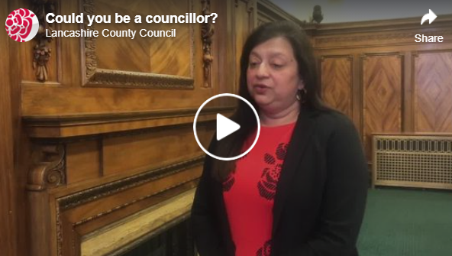
Could you #BeACouncillor and …make a difference to your local community?  Register now for our Info Eve on 22 Feb, and get all the information you need to help you make the next steps.  https://www.lancashire.gov.uk/elections/be-a-councillor/ | 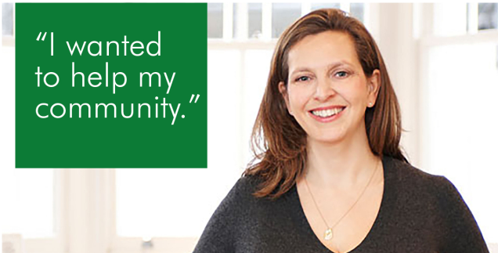
Register now for our online Information Evening on 22 Feb and find out how you can take the next steps to becoming a councillor.  https://www.lancashire.gov.uk/elections/be-a-councillor/ #BeACouncillor | [video]  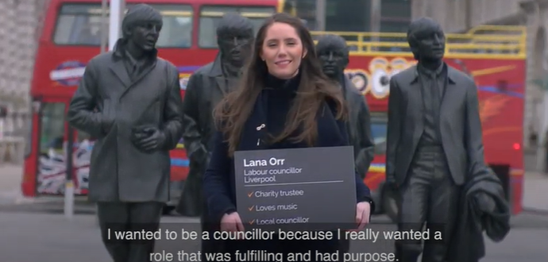
Could you #BeACouncillor and… help shape the future of Lancashire?  If you want to know more about the election process and the support available for new councillors, then register for our info event on 22 Feb. https://www.lancashire.gov.uk/elections/be-a-councillor/ | [animation]  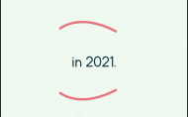
Could you #BeACouncillor and …make a difference in your area?  Come and find out more by registering to join our virtual Information Evening on Mon 22 Feb https://www.lancashire.gov.uk/elections/be-a-councillor/ | 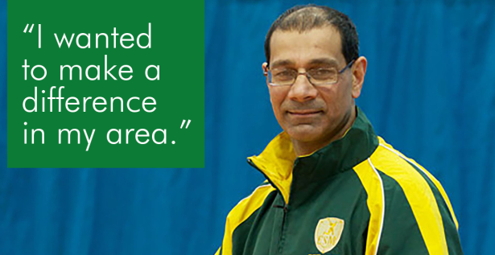
Could you #BeACouncillor and… improve local services?  If yes, then make sure you have registered for our Information Evening on 22 Feb.  You'll get all the info and support you need to take the next steps. https://www.lancashire.gov.uk/elections/be-a-councillor/ | 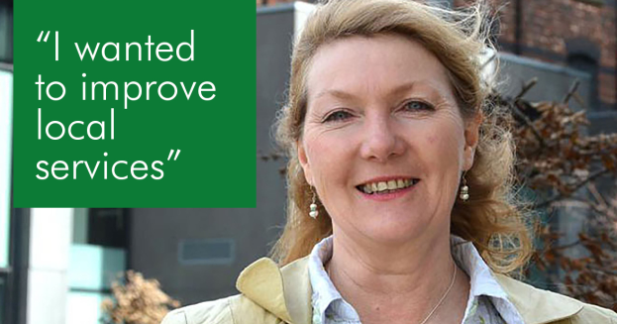
It's not too late to register for our virtual #BeACouncillor Info event taking place at 6.00pm this evening.  If you've been thinking about standing as a councillor, then register now. https://www.lancashire.gov.uk/elections/be-a-councillor/ | [animation]
Thank you to everyone who attended our #BeACouncillor Info Event yesterday.
If you weren't able to attend, but would still like to find out more, then visit: https://www.lancashire.gov.uk/elections/be-a-councillor/

Suggested posts for your account
Please post the following messages to your social media accounts.
Local Elections are due to take place in Lancashire in May 2021.

If you're passionate about representing your local area, and have been thinking about how you could #BeACouncillor, find out from @lancashirecc how you can take the next step. https://www.lancashire.gov.uk/elections/be-a-councillor/
With local elections taking place in May 2021 across Lancashire, have you thought about becoming a councillor?

If you have, then find out what support is available from @lancashirecc to help you #BeACouncillor. https://www.lancashire.gov.uk/elections/be-a-councillor/

